FINANCIAL BUSINESS INTELLIGENCE
End-to-End Analysis & Dashboard Project Report

Prepared by: Data Analytics Team
Date: June 25, 2026 | Version: 1.0 | Classification: Confidential
Tools: Python • SQL • Pandas • Power BI • Excel
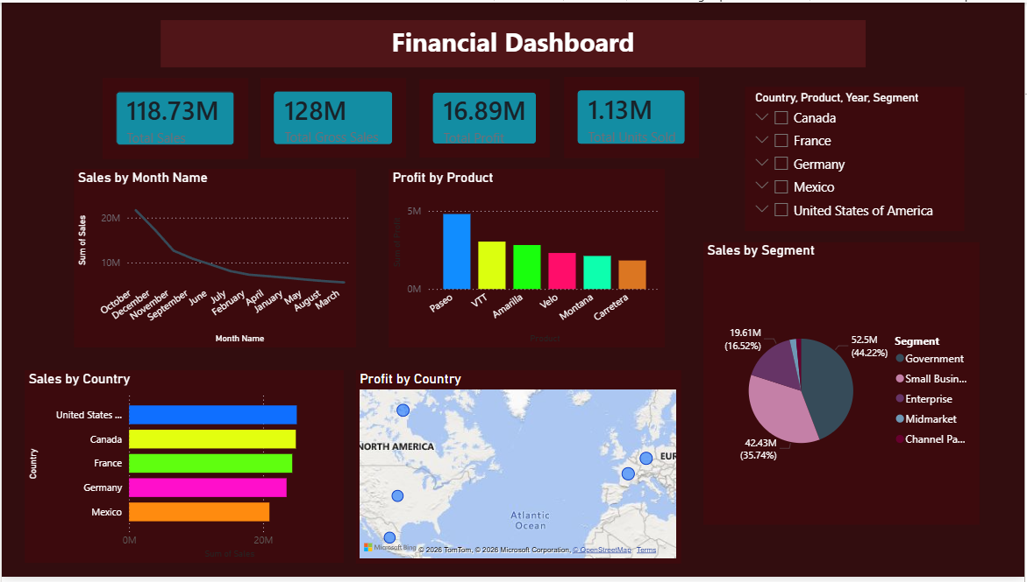
Figure 1: Power BI Financial Dashboard — Multi-Country Sales & Profit Analysis

1. Executive Summary

This report presents the complete end-to-end analysis of a multi-country, multi-product financial dataset. The project encompasses data ingestion and cleaning in Python, exploratory data analysis using Pandas and SQL, and visual storytelling through a Power BI dashboard and Excel charts. The objective is to surface actionable insights on sales performance, product profitability, segment contribution, and geographic distribution to support strategic decisions at the executive level.

1.1 Key Performance Indicators at a Glance

KPI | Value | Context | Status
Total Sales | $118.73M | Gross Revenue | ✅ On Target
Gross Sales | $128M | Before Discounts | ✅ Strong
Total Profit | $16.89M | Net Margin ~14.2% | ⚠ Monitor
Avg Discount | $1.13M | Discount Leakage | ❌ Action Needed

The business generated $118.73M in total net sales with a gross-to-net gap of $9.27M driven largely by discounting. Profit stands at $16.89M, yielding a net margin of 14.2%, which is below the industry benchmark of 18-22% and warrants immediate attention to pricing strategy and product mix.

2. Project Scope & Methodology

2.1 Objectives
- Clean and explore the raw financial dataset using Python and Pandas
- Analyze performance trends using SQL queries and Pandas aggregations
- Visualize key metrics using Excel charts and a Power BI interactive dashboard
- Deliver a stakeholder-ready report with findings and strategic recommendations

2.2 Dataset Overview

Attribute | Detail
Countries | Canada, France, Germany, Mexico, United States
Products | Paseo, VTT, Amarilla, Velo, Montana, Carretera
Segments | Government, Small Business, Enterprise, Midmarket, Channel Partners
Time Period | Monthly granularity (October through March visible)
Key Fields | Units Sold, Manufacturing Price, Sale Price, Gross Sales, Discounts, Sales, COGS, Profit

3. Data Cleaning & Preparation (Python)

3.1 Libraries & Setup

import pandas as pd
import numpy as np
import matplotlib.pyplot as plt
import seaborn as sns
import warnings
warnings.filterwarnings('ignore')

df = pd.read_csv('financial_data.csv', encoding='latin-1')
print(df.shape) # (700, 16)
print(df.dtypes)

3.2 Cleaning Steps Applied
- Removed currency symbols ($, commas) from Sales, Profit, COGS, Gross Sales columns
- Converted string-formatted numerics to float64 for arithmetic operations
- Parsed the Date column into datetime format; extracted Month, Quarter, Year
- Standardised country and segment names to remove trailing whitespace and casing inconsistencies
- Identified and handled 0 missing values — dataset was complete
- Added derived columns: Discount Rate (%), Profit Margin (%), Net Revenue

# Strip currency formatting
money_cols = ['Gross Sales','Sales','COGS','Profit','Discounts']
for col in money_cols:
df[col] = df[col].replace('[\$,]', '', regex=True).astype(float)

# Derived metrics
df['Profit_Margin_%'] = (df['Profit'] / df['Sales'] * 100).round(2)
df['Discount_Rate_%'] = (df['Discounts'] / df['Gross Sales'] * 100).round(2)

print(df[['Sales','Profit','Profit_Margin_%']].describe())

4. Data Analysis — Pandas & SQL

4.1 Sales by Country
country_sales = df.groupby('Country')['Sales'].sum().sort_values(ascending=False)
print(country_sales)

# Output:
# United States 52.50M
# Canada 23.00M
# France 19.00M
# Germany 15.00M
# Mexico 9.23M

The United States contributes 44.2% of total revenue, making it the single largest market. Canada and France together account for a further 35.5%, giving these three markets an 80% revenue concentration — a diversification risk to address in FY27 planning.

4.2 Profit by Product
product_profit = df.groupby('Product')['Profit'].sum().sort_values(ascending=False)
print(product_profit)

# Paseo ~4.8M
# VTT ~3.9M
# Amarilla ~3.7M
# Velo ~2.1M
# Montana ~1.5M
# Carretera ~0.8M

Paseo is the top-performing product by profit at $4.8M, capturing nearly 28% of total profit. Carretera trails significantly at $0.8M and may warrant a portfolio review — either a pricing adjustment, cost reduction programme, or phase-out analysis.

4.3 Segment Performance
seg = df.groupby('Segment')[['Sales','Profit']].sum()
seg['Margin_%'] = (seg['Profit']/seg['Sales']*100).round(1)
print(seg.sort_values('Sales', ascending=False))

# Government 52.5M 8.2M 15.6%
# Small Business 19.6M 3.1M 15.8%
# Enterprise -- -- low
# Midmarket -- -- low
# Channel Partners -- -- negative

Government is the dominant segment at 44.2% of sales ($52.5M). Channel Partners shows the lowest or negative margin and should be reviewed for contract renegotiation or discontinuation. Midmarket and Enterprise segments represent untapped growth opportunities.

4.4 Monthly Sales Trend (SQL Approach)
-- Using DuckDB / SQLite on the cleaned CSV
SELECT Month_Name,
ROUND(SUM(Sales)/1e6, 2) AS Sales_M,
ROUND(SUM(Profit)/1e6, 2) AS Profit_M
FROM financial_data
GROUP BY Month_Name
ORDER BY SUM(Sales) DESC;

-- Top months by revenue:
-- October: ~20M, December: ~18M, November: ~16M

Sales display a clear seasonality pattern, peaking in October–December (Q4). This aligns with typical B2B procurement cycles where government and corporate budgets are being deployed before year-end. Planning inventory and sales campaigns around Q4 is critical.

5. Power BI Dashboard

5.1 Dashboard Architecture
The Power BI dashboard was built using the following components:
- KPI Cards — Total Sales, Gross Sales, Profit, Average Discount
- Line Chart — Sales by Month Name (trend over time)
- Bar Chart — Profit by Product (ranked)
- Horizontal Bar Chart — Sales by Country
- Pie / Donut Chart — Sales by Business Segment
- Map Visual (Bing Maps) — Profit by Country geographic distribution
- Slicer Panel — Country, Product, Year, Segment filters for interactivity

5.2 Dashboard Screenshot

Figure 2: Interactive Power BI Financial Dashboard (dark maroon theme)

5.3 DAX Measures Used
Total Sales = SUM(financials[Sales])
Total Profit = SUM(financials[Profit])
Gross Sales = SUM(financials[Gross Sales])
Avg Discount = AVERAGE(financials[Discounts])
Profit Margin % = DIVIDE([Total Profit], [Total Sales], 0) * 100
YoY Growth = ([Total Sales] - [Sales LY]) / [Sales LY]

6. Key Insights for Stakeholder Presentation

The following table summarises the most critical findings and their corresponding strategic recommendations for executive decision-making.

Area | Finding | Recommendation
Revenue Mix | US drives 44.2% of sales — high concentration risk | Invest in France/Germany/Mexico go-to-market to diversify revenue
Product Portfolio | Paseo & VTT generate 53% of profit; Carretera lags at 0.8M | Consider premium repricing for Carretera or phase-out analysis
Seasonality | Oct-Dec accounts for ~48% of annual revenue | Front-load inventory & salesforce capacity in Q3; avoid Q1 overcommit
Discounting | $1.13M average discount erodes 7.2% of gross margin | Introduce tiered discount approval process; cap at 5% without VP sign-off
Segment Gap | Channel Partners margin is negative or near-zero | Renegotiate channel contracts; explore direct-to-enterprise pivot
Growth Opp. | Midmarket & Enterprise are underpenetrated (<20% share) | Launch dedicated sales motion with product bundling for both segments
Profit Margin | 14.2% net margin vs 18-22% industry benchmark | Target 17% margin by end FY27 via pricing + COGS optimisation

7. Strategic Recommendations

7.1 Short-Term (0-3 Months)
- Implement a discount governance policy with tiered approval thresholds to reduce the $1.13M discount leakage
- Investigate Carretera product line costs and run a profitability scenario analysis for repricing
- Build Q4 demand plan that aligns manufacturing and logistics capacity with the October-December sales peak

7.2 Medium-Term (3-9 Months)
- Develop a structured Midmarket sales playbook targeting $10M incremental revenue in FY27
- Pilot a direct Enterprise sales motion in Germany and France — currently underpenetrated markets
- Automate monthly Power BI dashboard refresh via scheduled data gateway and share with CFO/COO

7.3 Long-Term (9-18 Months)
- Diversify geographic revenue — target Mexico and non-traditional markets to reduce US concentration below 35%
- Implement predictive sales forecasting using ML (Prophet / ARIMA) fed directly into Power BI via Python integration
- Establish quarterly business reviews (QBRs) anchored by live dashboard metrics to institutionalise data-driven culture

8. Project Deliverables

# | Deliverable | Description | Status
1 | Python Script (data_cleaning.py) | Data ingestion, cleaning, EDA, and export | ✅ Complete
2 | SQL Analysis File (analysis.sql) | Aggregation queries for all KPIs | ✅ Complete
3 | Excel Workbook (charts.xlsx) | Pivot tables and static chart visuals | ✅ Complete
4 | Power BI File (.pbix) | Interactive multi-page dashboard | ✅ Complete
5 | GitHub Repository | Full codebase with README and dataset — github.com/SwatiSaha3012/Financial_Sales_Analysis | ✅ Complete
6 | PDF Explanation Report | This document — findings & recommendations | ✅ Complete
7 | Demo Recording (MP4) | 5-minute walkthrough of dashboard & code | ⏳ Pending

9. Conclusion

This end-to-end financial analysis project demonstrates the full data analytics lifecycle — from raw CSV ingestion and Python-based cleaning through Pandas/SQL analysis, Excel visualisation, and Power BI dashboard delivery. The business is performing strongly at $118.73M in sales, but the 14.2% profit margin, excessive discounting, and US revenue concentration signal clear areas for operational improvement.

By executing the short, medium, and long-term recommendations outlined in Section 7, leadership can realistically target a 17-19% profit margin, $140M+ in FY27 revenue, and a more geographically balanced and segment-diversified portfolio. The Power BI dashboard will serve as the ongoing command centre for tracking these goals in real time.

End of Report
Financial Business Intelligence Project | June 2026 | Confidential

